 | IQVIATM Work Instruction Randomization
Document Number and Revision:
CS_WI_BS002 Revision 15
Document Owner:  Carrie Eason | Author(s):  Ellen Hermes

PURPOSE
To describe the planning, production, review, distribution, and storage of randomization schedules.

SCOPE

  - This Work Instruction (WI) applies to all projects globally where IQVIA Biostatistics:
Produces randomization schedules
Works with randomization schedules produced by a third-party vendor or the customer

ROLES AND RESPONSIBILITIES
The following roles perform tasks described within this WI:

Role | Sections
Randomization Biostatistician (RB) | 6.1, 6.2, 6.3, 6.5, 6.6
Unblinded Quality Control (UQC) Reviewer/Unblinded Senior Biostatistical (USB) Reviewer  Note: This role and the role of UB may be performed by the same person. | 6.2, 6.3, 6.4, 6.5, 6.6
Statistical Team Lead (STL) | 6.1, 6.2, 6.4
Unblinded Biostatistician (UB)  Note: This role and the role of UQC/USB Reviewer may be performed by the same person. | 6.2, 6.3, 6.4
If a person does fill multiple roles in the above table, independent reviews should be maintained according to CS_WI_BS015, Approaches to QC.

DEFINITIONS
Randomization Biostatisticians: A small team of suitably experienced biostatisticians who are authorized to produce randomization schedules.

Randomization Implementer (RI): The third-party providing the interactive voice response (IVR) / interactive web response (IWR) system if utilized or the contact(s) at the site(s) who will implement the randomization schedule.
Actual randomization schedule: Randomization schedule in any format (electronic or hard-copy) detailing the treatment group/sequence that a subject will be assigned to.
Draft randomization schedule: Randomization schedule produced for review purposes only hence the structure or content may be changed between draft and actual versions. Draft randomization schedules must use a different seed than the actual randomization schedule.
Dummy randomization schedule: Randomization schedule produced for the purpose of development of programs by the blinded Biostatistical team. The dummy randomization schedule must use a different seed than the actual randomization schedule and will possibly use different treatment group/sequence labels (e.g. inclusion of “DUMMY” in the label) and a different block size, but will otherwise be identical.
Restricted-access secure electronic randomization location: A secure electronic storage area accessible only by the RBs.
Central Randomization Production Tracker: A spreadsheet filed on the Electronic Vault Information System (ELVIS) containing the following information for all randomization schedules produced by IQVIA RBs:
- Customer name
- Indication
- Protocol Name/Number
- Project code
- Type of randomization schedule generated (draft, dummy, actual)
- Name and location of RB
- Name and location of UQC/USB Reviewer
- Name and location of UB (if applicable)
- Date and time of generation of randomization schedule
- Date and time of distribution of randomization schedule
- Network location of randomization specification
- Network location of randomization schedule
- Date and time of each release of randomization schedule for unblinded analysis

MATERIAL AND EQUIPMENT
Not Applicable

PROCEDURE
The summary workflow diagrams for this work instruction are in Appendix A. These diagrams do not replace the following text, but rather provide an overview to assist in executing the process.

  - Production of Randomization Specifications (applies when IQVIA Biostatistics produce the randomization schedule)

No: | Who: | Step: | When:
6.1.1 | STL | Requests randomization support of the RB utilizing the GBIOS Randomization Team email address GBIOSRandomizationTeam@iqvia.com.  or by contacting a designated randomization statistician for an Early Clinical Development (ECD) contracted study with ECD Biostatistics providing randomization services. | Upon determination that IQVIA  Biostatistics will produce randomization material
 |  | Note: Randomization material may only be produced by an assigned RB.
6.1.2 | RB | Must define the requirements for the randomization schedule using the CS_TP_BS025, Randomization Specification. | According to the study timelines
6.1.3 | RB, with input from STL | Obtains the final protocol before producing the randomization specification. | Before producing the randomization specification
6.1.4 |  | May request information on study design from the STL.  Note: Must not disclose any information that could lead to unblinding (including planned seed number or block size).
6.1.5 |  | Confirms if partially unblinded data are required for any pre-lock unblinded analyses.
6.1.6 |  | Confirms if a dummy randomization schedule is required.
6.1.7 |  | Checks that the list of recipients of the randomization schedule is strictly limited to those who require it.
6.1.8 |  | Establishes the blinded/unblinded status of all reviewers of the randomization specification.
6.1.9 | RB | Produces the randomization specification which must include the following information:  - The number of subjects to be randomized.  - Whether kit/component identifiers are required.  - The number of records (randomization numbers or kit/component identifiers) required in the randomization schedule.  - The format and range of the randomization number and/or kit/component identifier.  - Whether kit/component identifiers are provided or require generating. | According to the study timelines

No: | Who: | Step: | When:
- Any requirements for replacement subjects.
- Any stratification factors (including site) including number of levels of each factor.
- Details of the treatment groups/sequences including ratio of subjects to each group/sequence.
- Block size and number of blocks required.
- Details of dynamic randomization methods.
- Whether randomization is central or distributed.
- Name and format of each file to be created including draft and any dummy randomization schedules.
- Whether each file will contain fully unblinded or partially unblinded information.
- The list of those authorized to receive draft, dummy (if applicable) and actual randomization schedules including contact details, list of the files to be provided, method of distribution, reason for distribution (for review/approval, for blinded program development or for implementation).
6.1.10 |  | Distributes the randomization specification to the STL, UQC/USB Reviewer, customer (if required), and the RI for review and/or approval.  Note: The seed must not be stated anywhere and the block size must be redacted if any reviewers are blinded team members.
6.1.11 |  | Files the authorized randomization specification in the restricted access secure electronic randomization location or unblinded electronic Trial Master File (eTMF) if available and destroys/deletes all other electronic and paper copies that do not form part of a complete audit trial. Refer to CS_WI_BS0237 (Management and Filing of Biostatistics Documentation) for processes related to filing. | After approval of the randomization specification

  - Review of Randomization Specifications (applies whether IQVIA Biostatistics or third-party vendor or customer produce the randomization schedule)

No: | Who: | Step: | When:
6.2.1 | STL | Requests the randomization specification author redacts all potentially unblinding information, including the seed number and the block size, from the specification prior to distributing it for review. | Prior to distributing for the review
6.2.2 | STL | Delegates the review and approval to an UB if potentially unblinding information cannot be redacted from the randomization specification.

No: | Who: | Step: | When:
Note: only applies if the specification has been produced by a third- party vendor or the customer.
If no UB available, contacts the GBIOS Randomization Team to get a RB assigned who can review and approve.
6.2.3 | STL or UB  or RB, and UQC/USB  Reviewer | Reviews the randomization specification according to CS_WI_BS015, Approaches to QC as applicable. | After the distribution for the review
6.2.4 |  | Documents comments using an appropriate format agreed with the vendor, or using CS_FM_BS007, Reviewer Feedback Form (RFF) if deliverable is produced by IQVIA Biostatistics. | During the review
6.2.5 | STL | Files communication on comment resolution in the eTMF (if available) if no potentially unblinding information is present in the randomization specification. Refer to CS_WI_BS0237 (Management and Filing of Biostatistics Documentation) for processes related to filing. | After completing the review
6.2.6 | UB, UQC/USB  Reviewer | Files the communication on comment resolution in the unblinded eTMF (if available) if potentially unblinding information is present in the randomization specification. Refer to CS_WI_BS0237 (Management and Filing of Biostatistics Documentation) for processes related to filing.
6.2.7 | STL or UB  or RB | Approves the randomization specification if requested.

  - Production of Randomization Schedule (applies when IQVIA Biostatistics produce the randomization schedule)

No: | Who: | Step: | When:
6.3.1 | RB | Generates a randomization schedule according to the approved randomization specification using SAS Proc PLAN and complies with all processes described in CS_WI_BS013, Derived Datasets. In particular, the RB:  - Must use a different seed for the actual randomization schedule to that used for draft and dummy schedules.  - Must use original seed if an existing randomization schedule is being re-created or extended.  - Must use different seeds if multiple actual randomization schedules are required.  - Produces output files in the format(s) stated in the randomization specification.  - Indicates either “draft”, "dummy" or “actual” in all filenames.  - Appends “_draft” to the treatment group (or kit) identifier in draft schedule output files (must append to variable value, may additionally append to variable label). | After the authorization of the randomization specification

No: | Who: | Step: | When:
- Appends “_dummy” to the treatment group identifier in dummy schedule output files (must append to variable value, may additionally append to variable label).
- Must verify block size is not present in any draft or dummy schedule output files provided to blinded personnel.
- Consider use of a dummy block size in any draft or dummy schedule output files if small numbers of records within strata could reveal the block size.
- Must use masked identifiers for treatment labels such as “A” and “B” when partial unblinded output files are needed.
- Produces output files. The files to support the implementation of the schedule should conform to CS_WI_RM0284, General and Trial Master File (TMF)-Specific Document Quality – Good Documentation Practices, to the degree allowed by the systems of the randomization implementation. The files to be placed in the clinical study report must fully conform to Good Documentation Practices.
6.3.2 | RB | Distribute randomization schedule to UQC/USB Reviewer for review. | After producing randomization schedule
6.3.3 | RB, with input from UQC/USB  Reviewer | Incorporates review comments received from UQC/USB Reviewer and any other authorized reviewers on draft randomization schedule(s) into the actual and dummy (if required) randomization schedules. | After UQC/USB review
6.3.4 | UB | In cases where randomization has been outsourced to a third-party vendor and a dummy randomization schedule is required (example for an unblinded interim or Data Monitoring Committee (DMC) analysis), but the third-party vendor is unable to produce a dummy schedule, the same checks specified in 6.3.1 related to creating a dummy randomization schedule applies to ensure the dummy randomization differs from the actual randomization. | Prior to implementing dummy randomization scheme

  - Review of Randomization Schedules (applies whether IQVIA Biostatistics or third-party vendor or customer produce the randomization schedule)

No: | Who: | Step: | When:
6.4.1 | UQC/USB  Reviewer | Reviews the draft, dummy (if required) and actual randomization schedule(s) according to CS_WI_BS015, Approaches to QC as applicable. | After the distribution for the review
6.4.2 |  | Documents comments using an appropriate format agreed with the vendor, or using CS_FM_BS007, Reviewer Feedback Form (RFF) if deliverable is produced by IQVIA Biostatistics. | During the review

No: | Who: | Step: | When:
6.4.3 | STL or UB | Reviews the draft randomization schedule for format, content and structure. If the draft schedule contains potentially unblinding information such as block size, then delegate to an UB.
6.4.4 | UQC/USB  Reviewer | Requests the RB to file the communication on comment resolution in the unblinded eTMF if available. Refer to CS_WI_BS0237 (Management and Filing of Biostatistics Documentation) for processes related to filing. | After the review

  - Distribution of Randomization Schedules (applies when IQVIA Biostatistics produce the randomization schedules)

No: | Who: | Step: | When:
6.5.1 | RB | Only distributes the draft, dummy (if required) and actual randomization schedule to recipients documented in the randomization specification.  Note: Distribution of schedules produced for open-label studies should still be restricted to those performing the randomization at least until enrolment is complete, and may be further restricted as per agreement per the customer. This is to prevent the introduction of bias into the enrolment process through knowledge of subsequent treatment assignments. | After the production
6.5.2 |  | Distributes the draft, dummy (if required) and actual randomization schedule in the format(s) stated in the randomization specification.
6.5.3 |  | Password protects electronic files if distributing via email and sends passwords in a separate email communication.  When distributing the actual randomization schedule, adds encryption to the email.
6.5.4 |  | Password protects electronic files if distributing on electronic media and sends passwords in a separate communication to the couriered electronic media.
6.5.5 |  | Marks hard-copies “CONTROLLED COPY” before distributing.
6.5.6 |  | Seals hard-copies or copies on electronic media to be couriered in an envelope marked “CONFIDENTIAL” and for attention of addressee only.
6.5.7 | UQC/USB  Reviewer | Refer to CS_WI_BS003, Unblinding, for details regarding the review of the distribution of randomization schedules at time of study unblinding. | Prior to distribution
6.5.8 | RB | Request RIs to confirm destruction/deletion of all copies of draft randomization schedules sent for review purposes prior to issuing actual randomization schedule. | Prior to distribution of the actual randomization schedules
6.5.9 |  | Completes the Central Randomization Production Tracker on ELVIS for each draft, dummy or actual randomization schedule distributed.

  - Storage of Randomization Schedules (applies when IQVIA Biostatistics produce the randomization schedule)

No: | Who: | Step: | When:
6.6.1 | RB | Files all electronic versions of draft, dummy and actual randomization schedules, the SAS program used to create them, corresponding log and output files and any electronic QC output in the restricted access secure electronic randomization location or unblinded eTMF as appropriate. | After the production
6.6.2 |  | Completes the Central Randomization Production Tracker on ELVIS for each draft, dummy or actual randomization schedule filed.

- SUPPORTING DOCUMENTATION

DOCUMENT NUMBER | TITLE
ESOP References
7.1 CS_FM_BS007 | Reviewer Feedback Form
7.2 CS_TP_BS025 | Randomization Specification
7.3 CS_WI_BS013 | Derived Datasets
7.4 CS_WI_BS015 | Approaches to QC
7.5 CS_WI_RM0284 | General and Trial Master File (TMF)-Specific Document Quality - Good Documentation Practices
7.6 CS_WI_BS0237 | Management and Filing of Biostatistics Documentation
7.7 CS_WI_BS003 | Unblinding

- SUPERSEDES

DOCUMENT NUMBER | TITLE | REVISION NUMBER
8.1 CS_WI_BS002 | Randomization | 14

- MODIFICATION FROM PREVIOUS REVISION
CHANGE | SECTION REFERENCE | JUSTIFICATION
Changes in document owner and Authors | Header | Changes in BIOS eSOP group
General wording updates | Throughout | For clarity and consistency with other WIs
Added text to describe how to request a randomization for ECD studies with ECD Biostatistics providing randomization services | 6.1.1 | Process not described in previous version of document
Re-worded requirements to conform to Good Documentation Practices | 6.3.1 | For clarity
Added that emails sending randomization material should be encrypted | 6.5.3 | Best practice for handling Level 3 data
Referenced CS_WI_BS003 for QC of the distribution | 6.5.7 | This is covered in CS_WI_BS003
Removed QC of the storage of randomization materials | 6.6.3 | Not required since set up of secure area is required

- APPENDICES

  - Appendix A: Randomization Workflow

Appendix A: Randomization Workflow
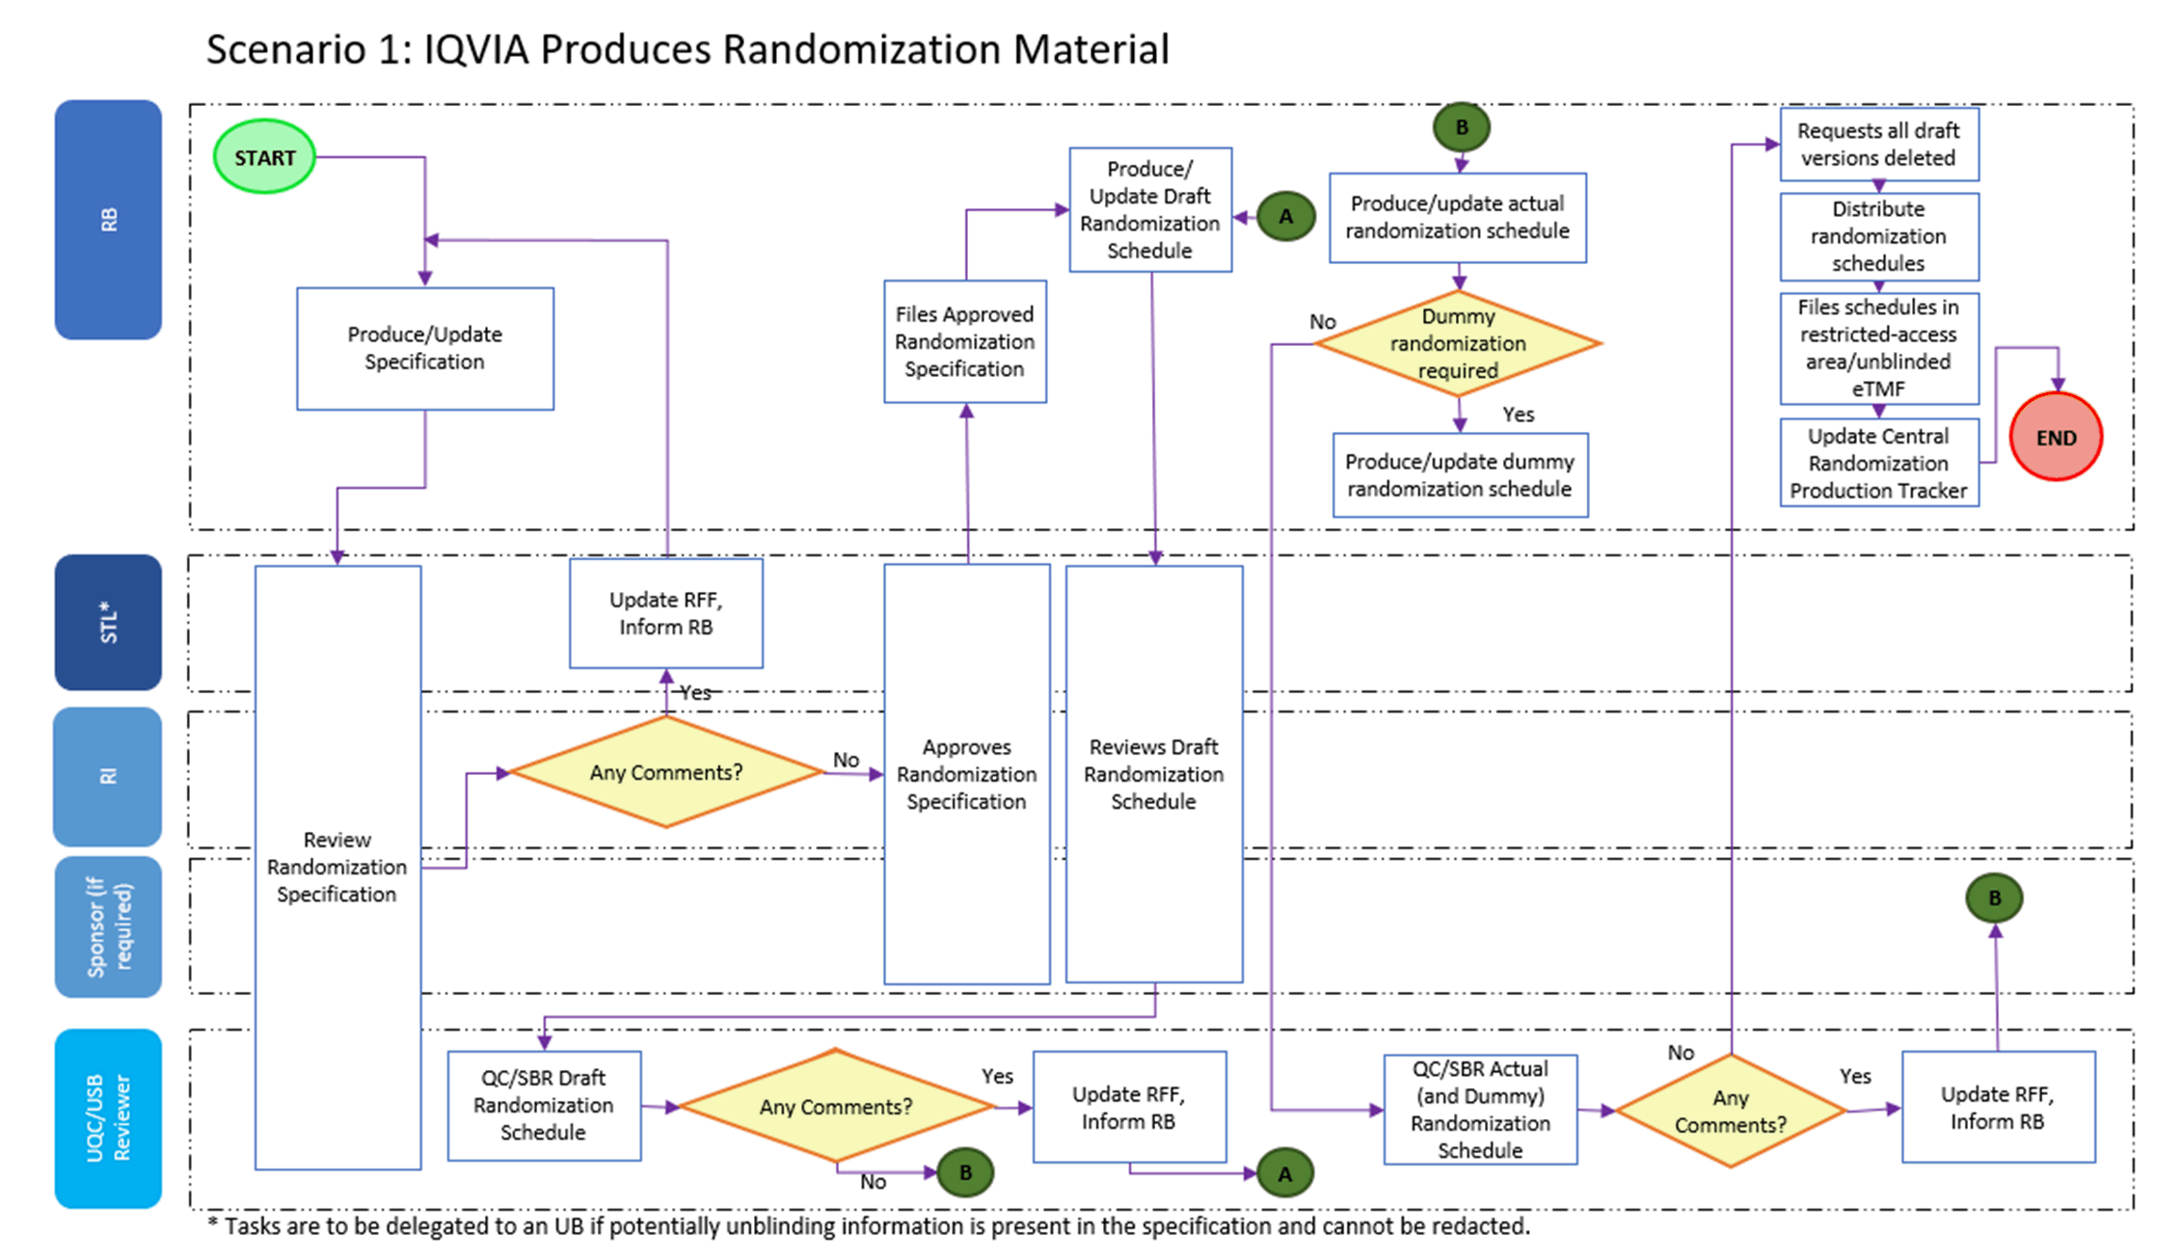

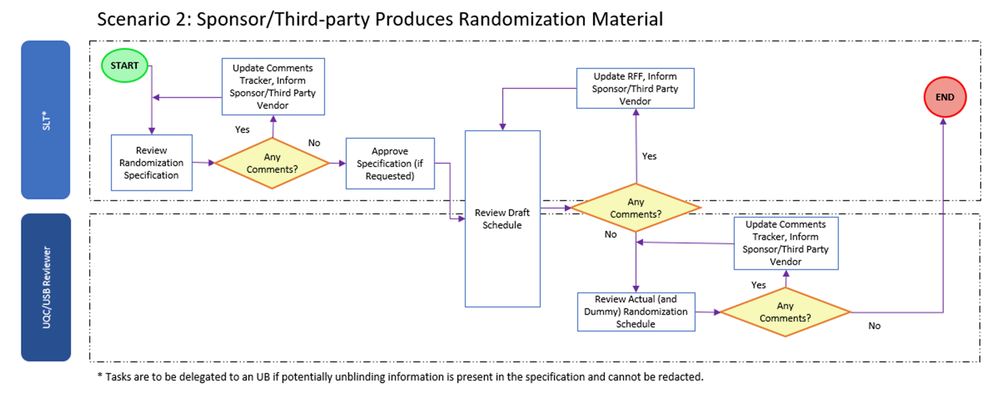

Page 12 of 12
Copyright © 1999, 2000, 2003, 2006, 2008-2011, 2013, 2014, 2016, 2018, 2020, 2022 IQVIA. All rights reserved. The contents of this document are confidential and proprietary to IQVIA Holdings, Inc. and its subsidiaries. Unauthorized use, disclosure or reproduction is strictly prohibited.

Standard Operating Procedure Approval Signature(s)
This is a representation of an electronic record that was signed electronically in Content Server.
This page is the manifestation of the electronic signature(s) used in compliance with the organization’s electronic signature policies and procedures
Refer to Signatories CV for Business Title.

UserName: Bickford, Emma (q637065) Title:
Date: Monday, 26 September 2022, 11:54 AM Eastern Daylight Time Meaning: Signing this Document Indicates My Approval
================================================

UserName: Ranjan, Santosh (q723916) Title:
Date: Thursday, 29 September 2022, 01:26 PM Eastern Daylight Time Meaning: Signing this Document Indicates My Approval
================================================

